**PROJECT REPORT**

**PROJECT TITLE**: BUILD AN EVENT MANAGEMENT SYSTEM USING SALESFORCE ASSOCIATE

01.INTRODUCTION

1.1 Overview:

The project aim is to provide real-time knowledge for all the students who have basic knowledge of Salesforce and Looking for a real-time project. This project will also help to those professionals who are in cross-technology and wanted to switch to Salesforce with the help of this project they will gain knowledge and can include into their resume as well.

1.2 Purpose:

Event management is the process of creating and maintaining an event. This process spans from the very beginning of planning all the way to post-event strategizing.

At the start, an event manager makes planning decisions, such as the time, location, and theme of their event. During an event, event managers oversee the event live and make sure things run smoothly. After an event, event managers are tasked with reviewing event data, submitting KPI and ROI findings, and staying on the ball for any post-event offerings.

All different branches of planning go into event management, including various types of  
sourcing, designing, regulation checks, and on-site management. In event management, you  
could be in the process of creating a conference, a product launch, an internal sales kick-off, or even a wedding. Really, any event that requires considerable planning and execution is event management.

02.Problem Definition & Design Thinking:

2.1 Empathy Map

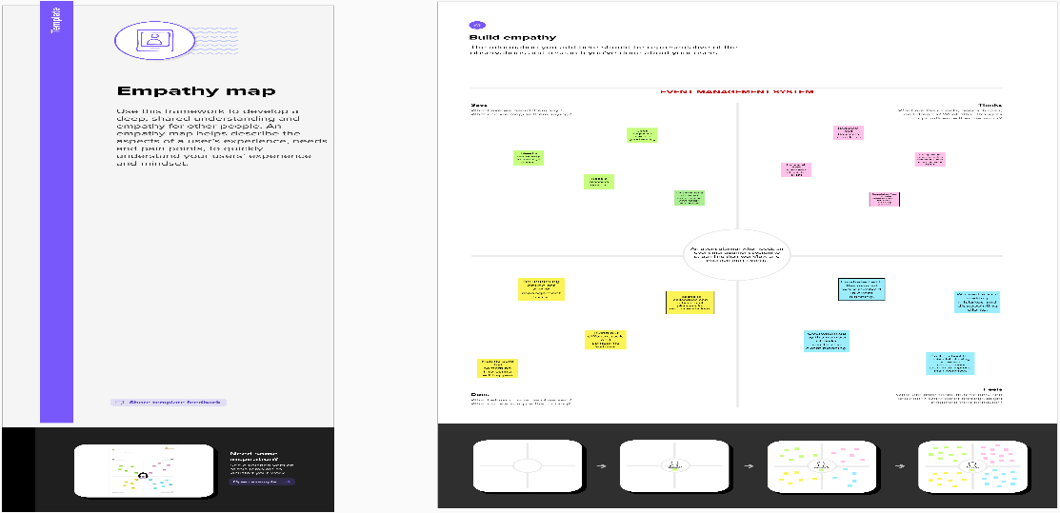

2.2 Ideation & Brainstorming App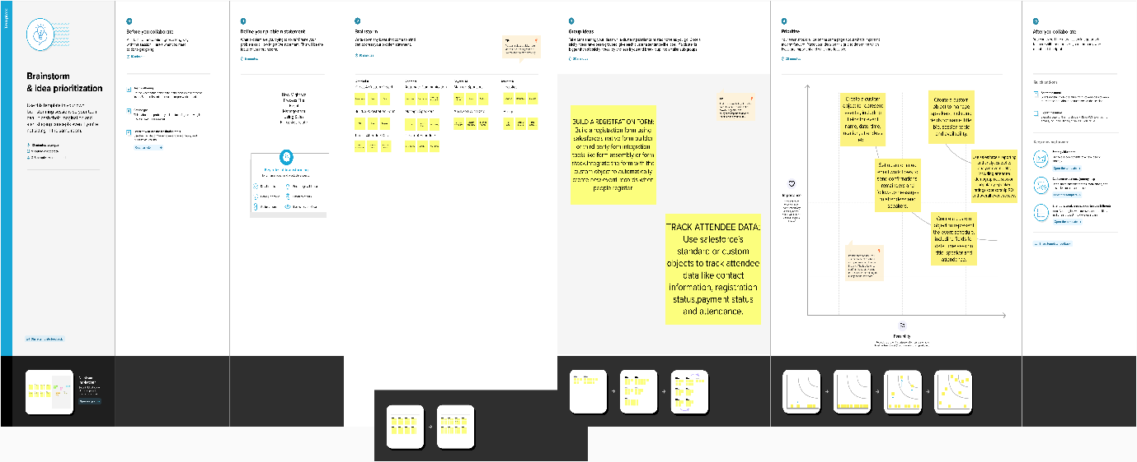

03.Result

3.1 Data Model

|  |  |
| --- | --- |
| **Object Name** | **Fields in the Object** |
| EVENT | |  |  | | --- | --- | | Field Label | Data Type | | City | Text | | Start Date | Date/Time | | End Date | Date/Time | |
| ATTENDEE | |  |  | | --- | --- | | Field Label | Data Type | | Id | Auto Number | | Phone | Phone | | Email | Email | | Tickets | Picklist | |
| SPEAKER | |  |  | | --- | --- | | Field Label | Data Type | | Bio | Text Area | | e-mail | Email | |

|  |  |
| --- | --- |
| **Object Name** | **Fields in the Object** |
| VENDOR | |  |  | | --- | --- | | Field Label | Data Type | | e-mail | Email | | Phone | Phone | | Service Provider | Text | | Event Name | Look-up Relationship | |

3.2 Activity & Screenshot

**01.OBJECT**

* Click the gear icon and click setup

* Go to Object Manager

* Create Custom Objects for

**1. Events**

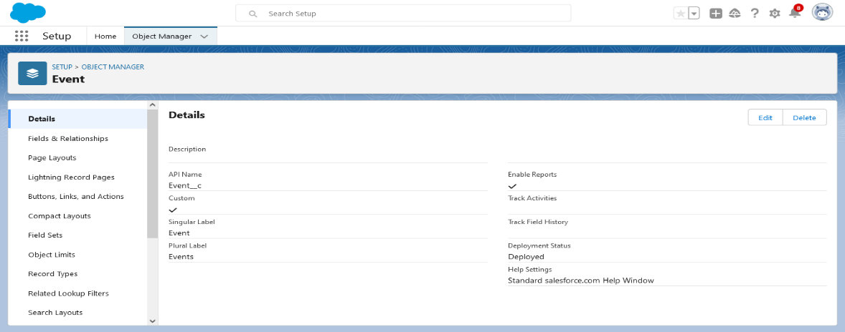

**2. Attendees**

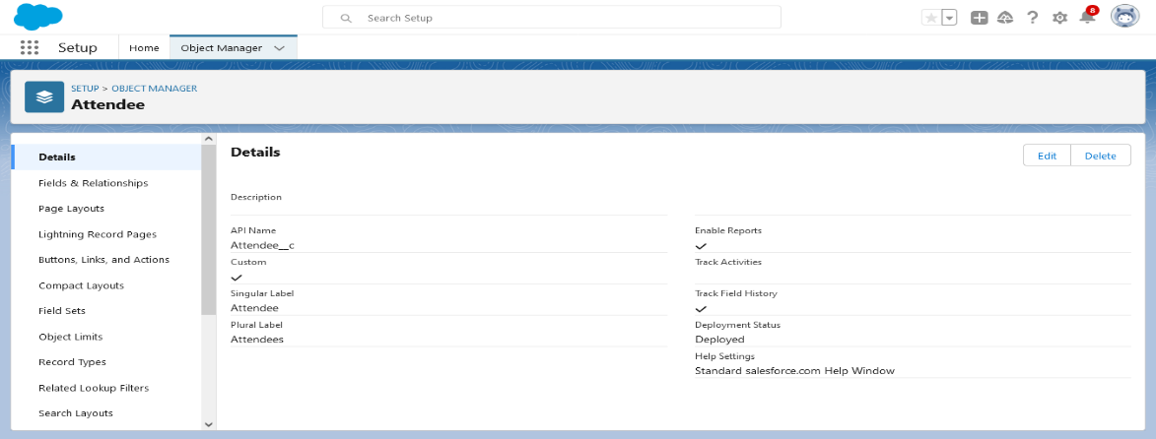

**3. Speakers** 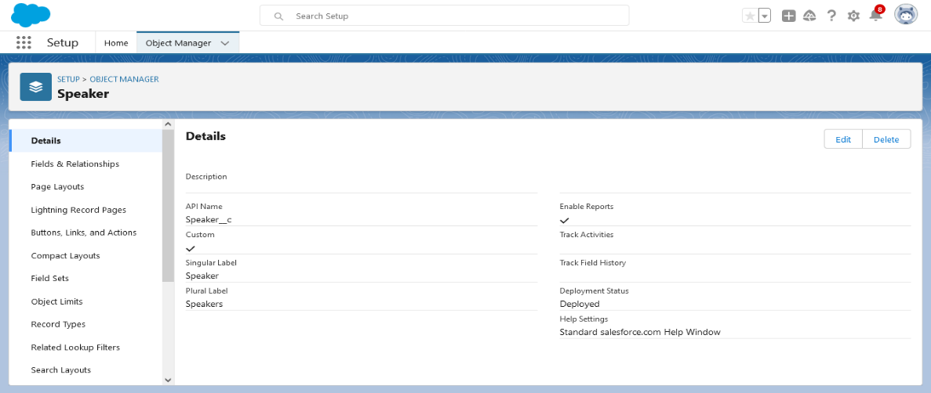

**4. Vendors**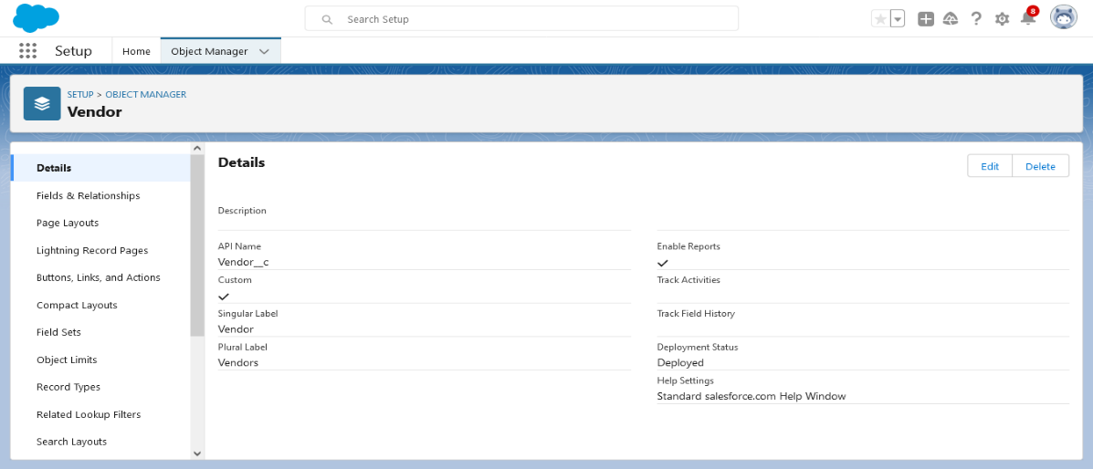

**02.TAB**

* Creating tabs for all custom objects

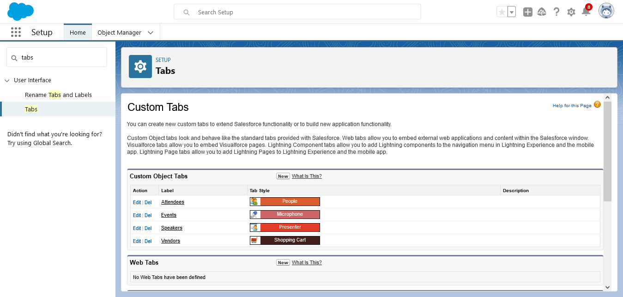

**03.APPLICATION**

* From setup search app manager in quick find

* Select app manager

* Click new lightening app

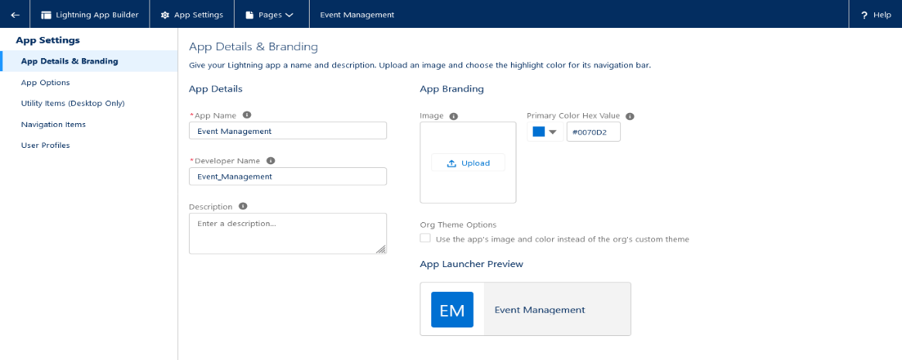

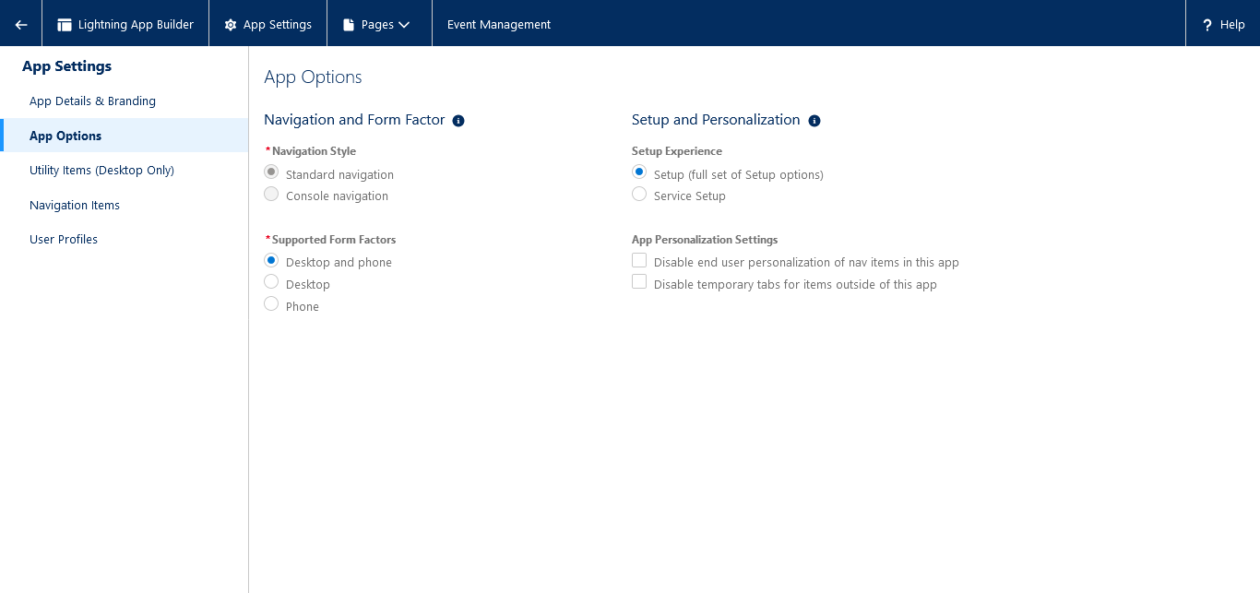

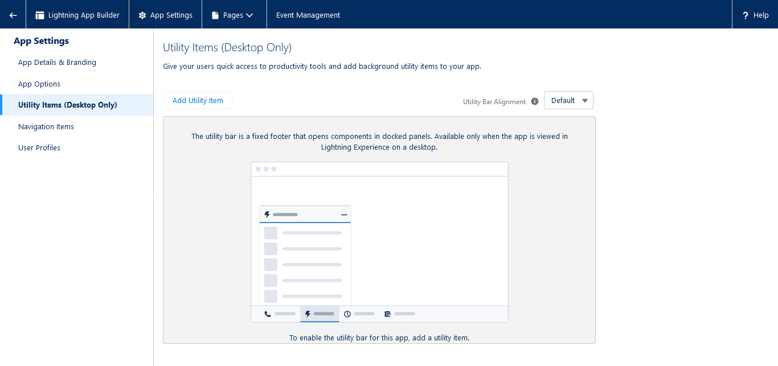

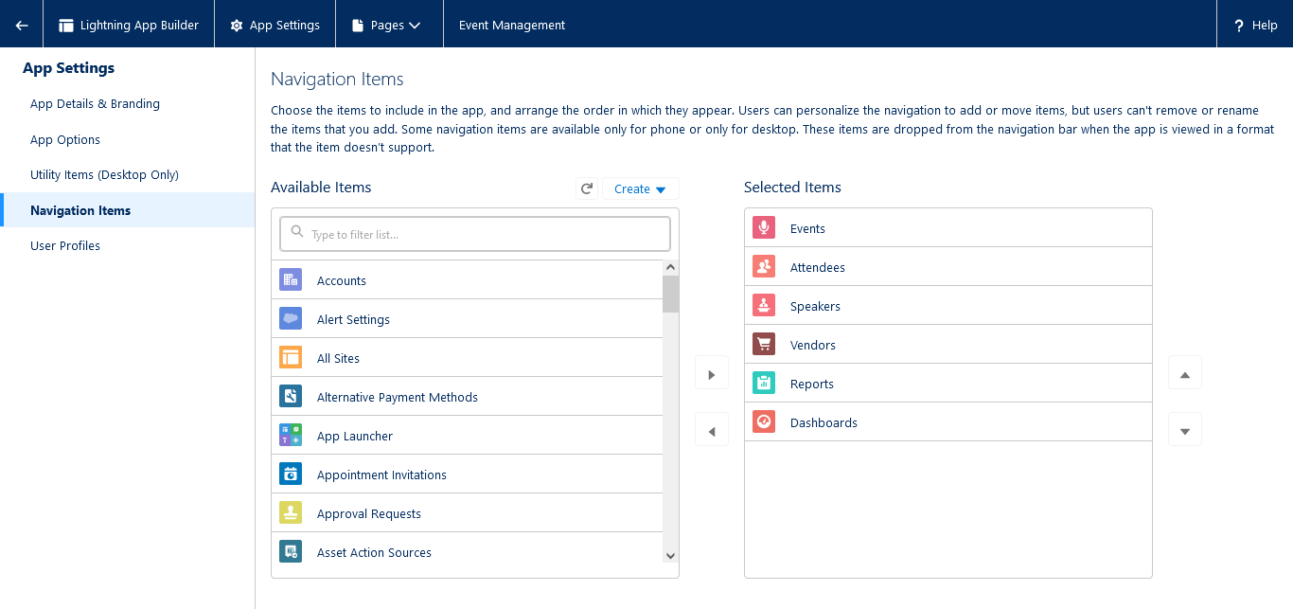

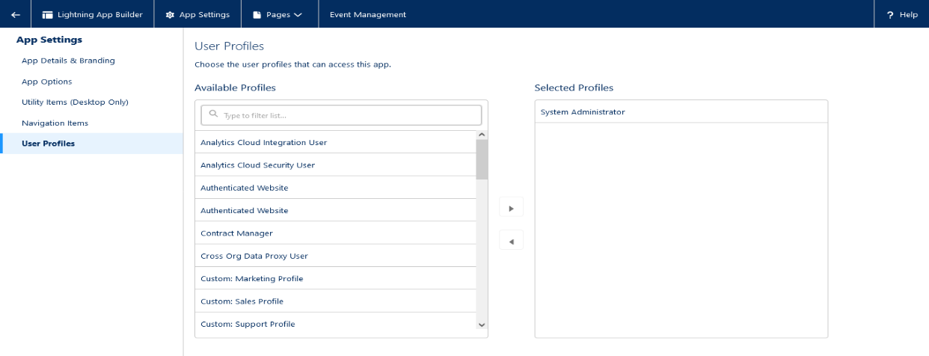

**04. FIELDS**

* Select setup

* Click the object manager

* Select event

* Select fields and relationship

* Click new

**1.EVENT**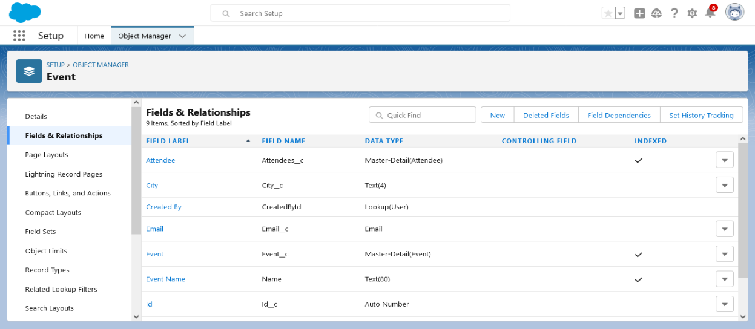

**2.ATTENDEE**

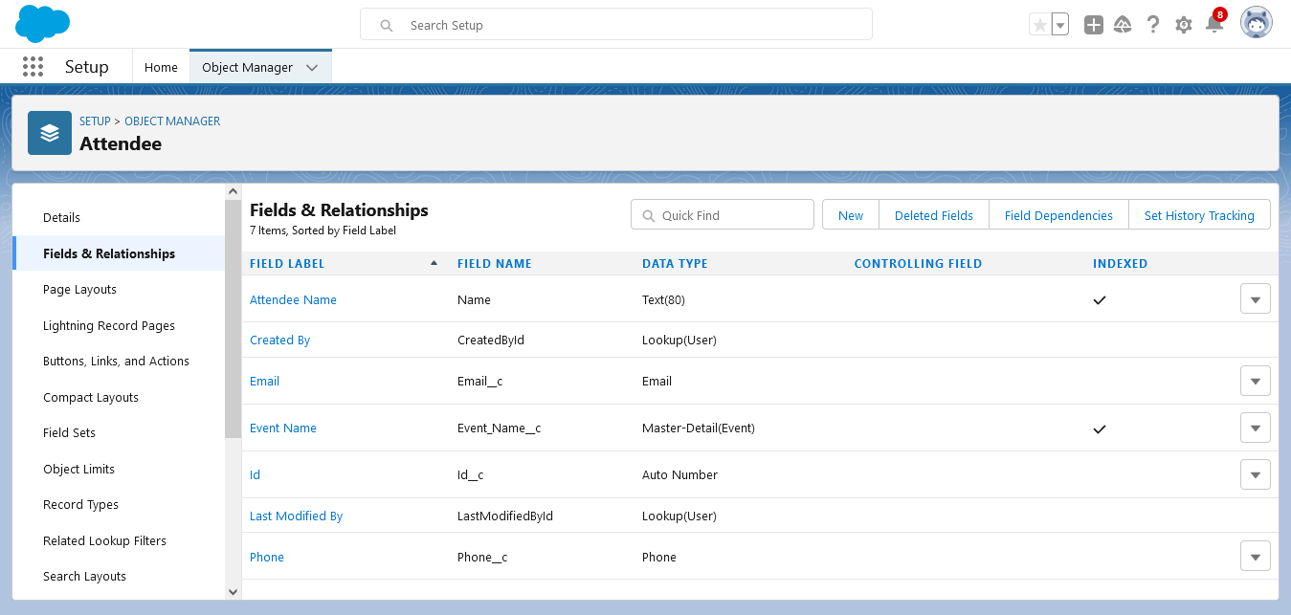

**3. SPEAKER**

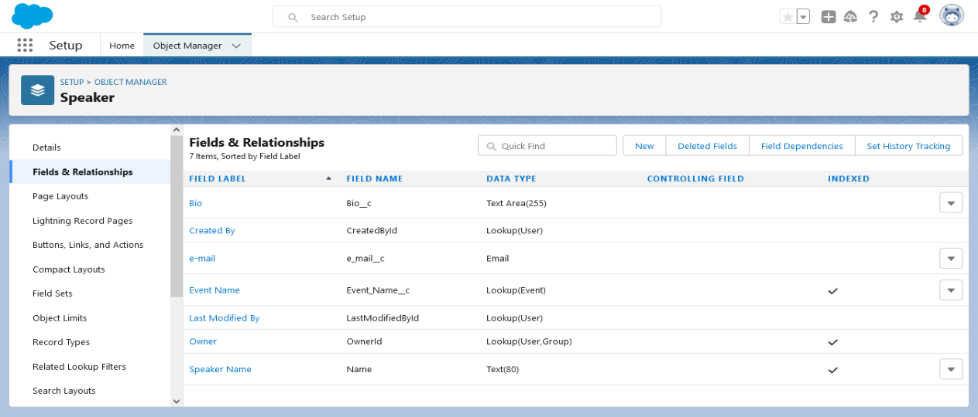

**4.VENDOR**

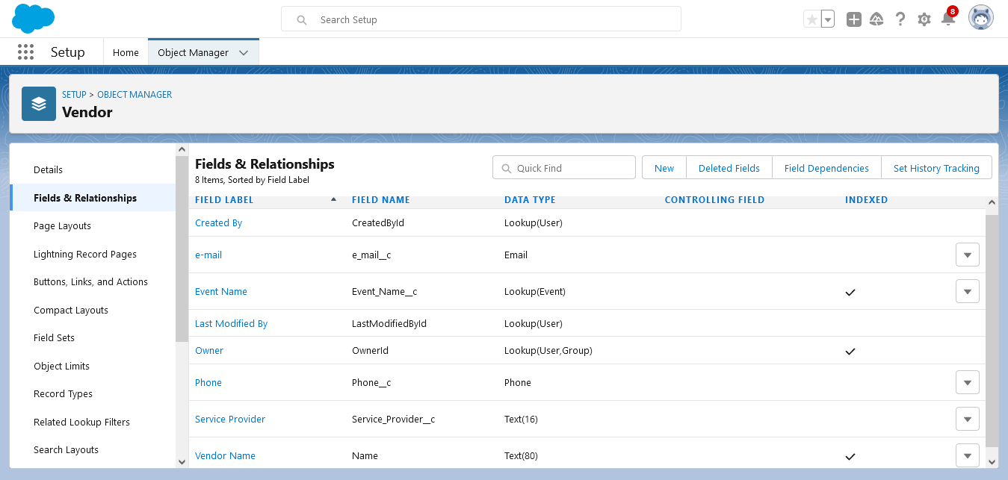

**05. PROFILES**

* From setup search profiles in quick find

* Select Profiles, find standard user

* Click clone

* For profile name, enter

* **EVENT USERS PROFILE**

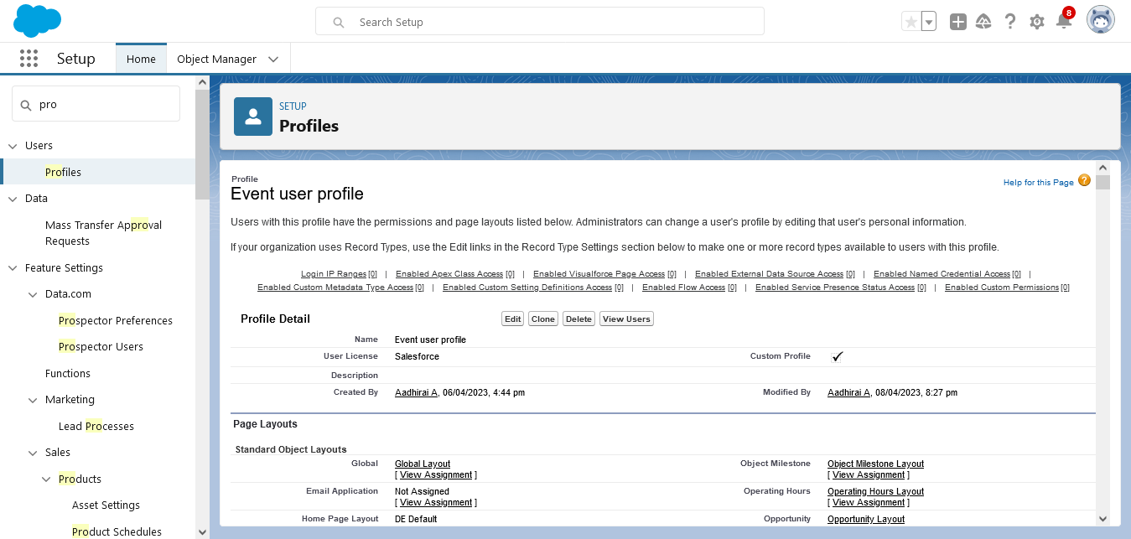

* **EVENT VENDORS PROFILE**

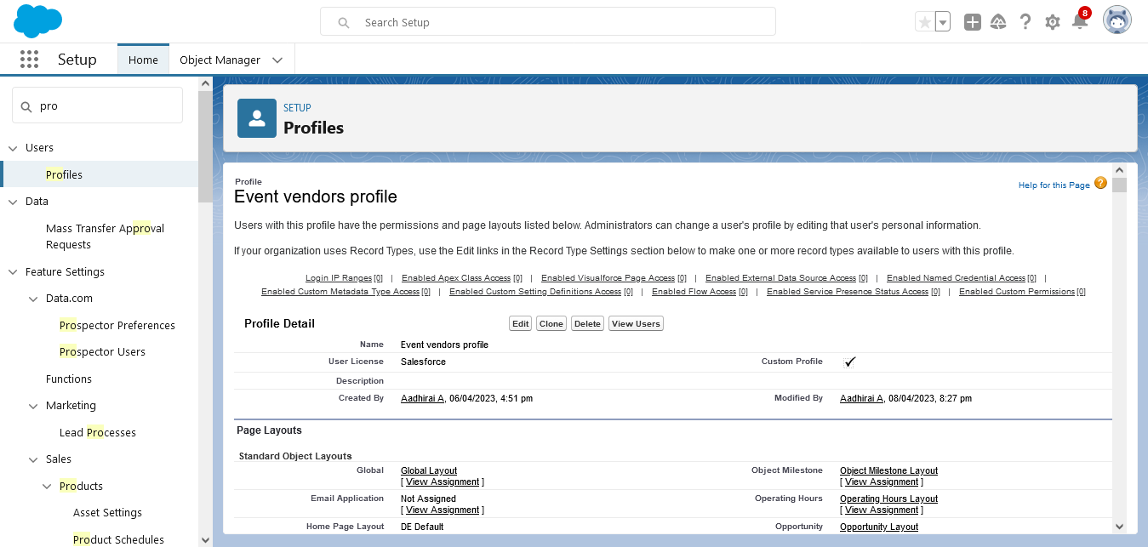

**06.USER**

* Type users in quick find

* Select users

* Click new users

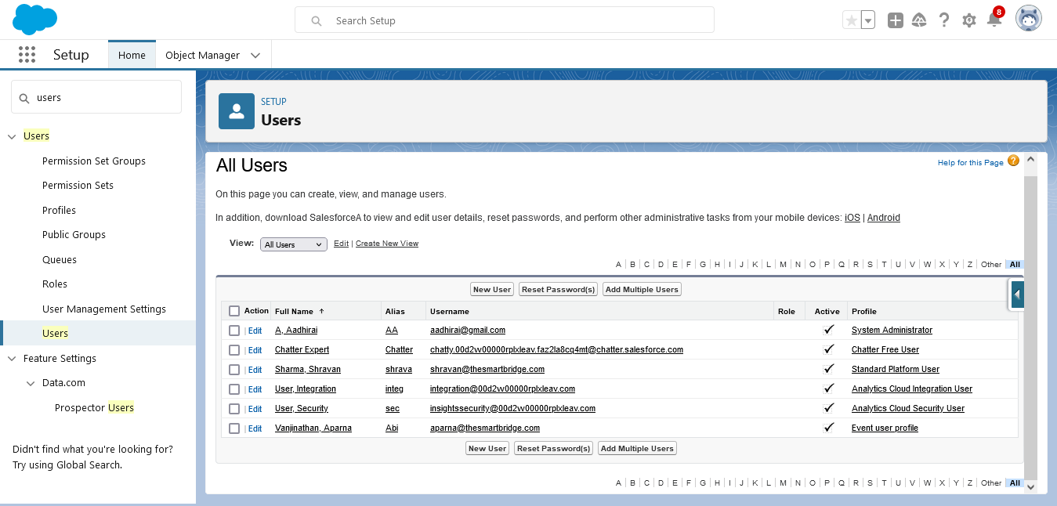

**07.PERMISSION SETS**

* Search permission sets in quick find

* Select permission set

* Click on new

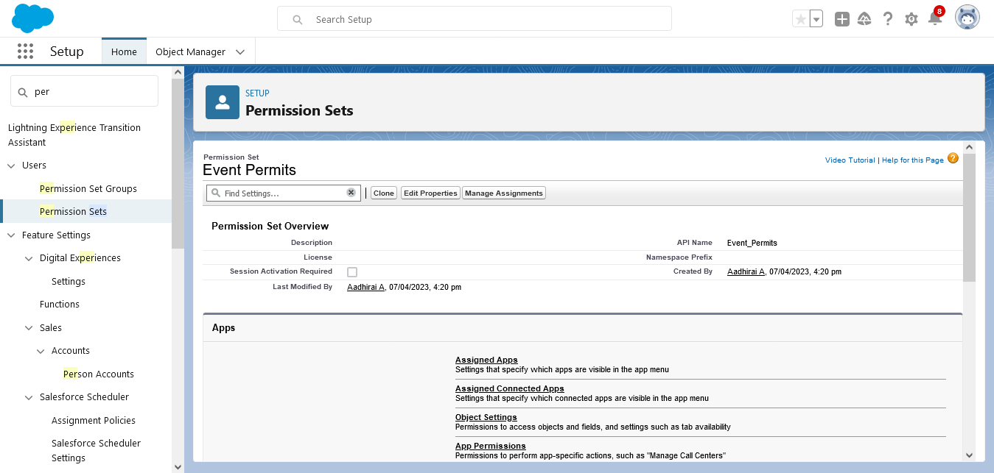

**08.REPORT**

* Go to App launcher

* Select reports

* Click new report

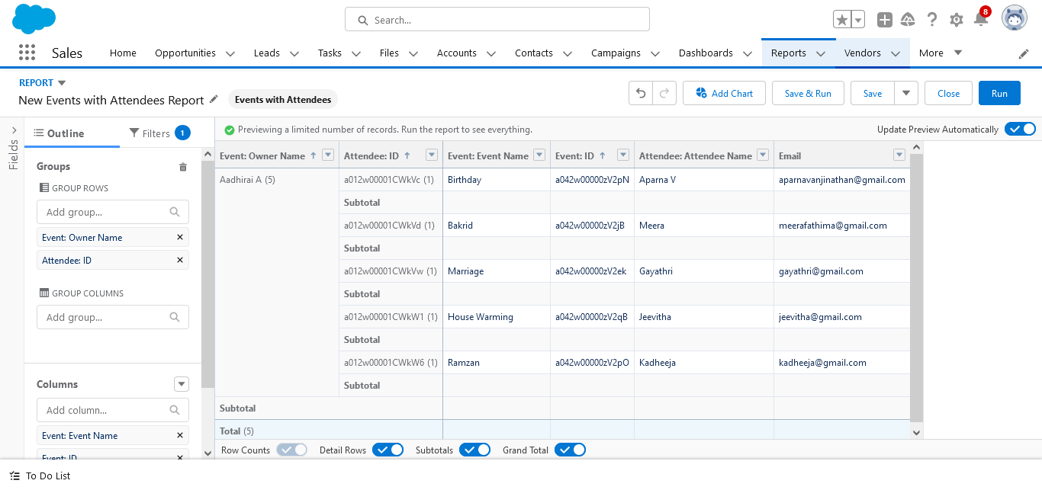

04. Trailhead Profile Public URL

Team Lead - <https://trailblazer.me/id/aadha60>

Team Member 1 - <https://trailblazer.me/id/aparv98>

Team Member 2 - <https://trailblazer.me/id/gayam37>

Team Member 3 - <https://trailblazer.me/id/jjeevi12>

05. Advantages & Disadvantages

**ADVANTAGES**

**\*** Best event planning

* End to end execution

* Improve customer services and satisfaction

* Smooth execution of planned ideas

* Saves time and money

* Maintain best account history

**DISADVANTAGES**

* Cost of event management varies negotiating contracts with event organizers

* Loose coupling

06. APPLICATIONS

* Private sectors

* Public sectors

* Government sectors

* Educational sectors

07.CONCLUSION

A description of the background and context of the project and its relation to work already done in the area. Made statement of the aims and objectives of the project. The description of purpose, scope, and applicability.

We understand the problem domain and produce a model of the system, which describes operations that can be performed on the system. We included features and operations in detail, including screen layouts.

Finally the system is implemented and tested according to test cases.

08. FUTURE SCOPE

* We can add printer in future

* We can give more advance software for event management system including more facilities.

* We will host the platform on online servers to make it accessible worldwide.

* Money-making

* Diverse designation

* Compensation through passion